**CS 422 Group 4 Project Report**

**Group Members**

* **Luqmaan Baiyat** - lbaiya2@uic.edu
* **Kathleen Mancillas** - [manclls2@uic.edu](mailto:manclls2@uic.edu)
* **Keval Patel** - kpate283@uic.edu
* **Jose E. Rodriguez** - jrodr41@uic.edu
* **Mohammed Shafiuddin** - mshafi2@uic.edu

**Problem Statement**

Over the course of the last few years, opioid related addictions have been on the rise in the United States.

Opioids work by blocking pain signals from the brain to the body. Opioids are commonly prescribed as different medicines to patients who have severe to moderate pain. Common scenarios where they are prescribed include injuries and surgeries. Not all patients who take opioids as medication understand the dangers associated with taking them, which can lead to opioid addiction and abuse. Different manners that opioids are abused include going over prescribed dosages, using them at a time where it’s not prescribed for the person, and also switching to different forms of opioids such as heroin. Regardless of how informed patients are about the dangers, they run the risk of building a higher tolerance to the drug, and overdosing.

In order for patients to safe while using opioids as medicine, they should take their medication at the prescribed time and keep track of their dosage usages and timings.

**GR1 Analysis Section**

**Observations and Interviews**

**Interview 1:** A senior who is retired as building inspector from now on will be addressed as subject, she is in her late sixties is suffering from pain in her legs around the knee, she has been diagnosed with a medical condition known as Peripheral Vascular Disease (PVD), which is caused by the blood clots in her blood vessels around her legs and other areas of the body. I have observed that she feels uncomfortable while walking and standing up due to the pain in her legs. She had surgery on both of her legs about four years ago. Now, to alleviate her pain she has to take medications like Tylenol 3 contains codeine which is opium class of drugs that induces the sedation which makes a person to sleep and can be addictive while being helpful to alleviate the pain, she also takes Aspirin for pain. The subject is trying not to become addicted to this medication.

Subject has met her longtime family friend after some years at Church’s chicken in her suburban Chicago neighborhood. Subject was surprised to see her friend walking around with no cane and a pain in her legs, her friend was also suffering from a similar condition as subject’s when she last saw her. After investigating that how her friend got well, subject came to know from her friend that she was using turmeric powder along with black seed oil every day for at least 3 years to treat her pain, therefore, subject now have started to do the same, she have brought the turmeric powder and black seed oil from her neighborhood herbal store. After using for few months now subject claims that she feels better than pre turmeric days. Now her pain at times becomes less severe.

Subject has short time memory loss and the drowsiness from the pain medication causes the subject to forget that whether she has taken her medicine or not, and sometimes mistakenly she takes the medication twice. Furthermore, the labels on medication does not specify the purpose of medication and she sometimes takes the wrong medication.

The subject feels that she gets confused and it makes it difficult for her to decide whether or not she should take these pain medications. She sees these medications helps her to alleviate her pain, at the same time it makes her drowsy and incapacitates her from performing her daily tasks

Subject fears that she might become addicted to these medications, she hopes her turmeric treatment one day will reduce her medication dependency. She has been making attempts to skip dosage and try to exercise so that she might be able to stay away from taking her addictive medications.

Problem learned:

* She knows that this medication is addictive and fears she might become addictive and dependent.
* Subject have trouble keeping track of dosage and the type of medication.
* Subject trying to find other natural methods like turmeric, exercising seems to be a more acceptable way to cure the pain.
* Skipping dosage from the fear of getting addicted - it could be harmful to skip the dosage when there is a dire need to stay alive, because the pain medication also work as blood thinner that prevents blood clotting which can be fatal.
* Influenced by friend as a resource to find the alternative natural plan to use turmeric and black seed oil.

**Interview 2**: Interviewee 2 is a Mexican man, nearly 50 years old, who has in the past taken a large number of medications (mostly pain relievers) mainly to alleviate back pain. The origin of the back pain comes from an accident suffered at his workplace more than a decade ago.

The man keeps his medication in a kitchen cabinet, neatly organized, and remembers to take it by memory. When asked about whether he thinks he could become, or is, addicted to his pain relievers, he seemed completely unconcerned and stated that taking them was nothing more than a chore to him.

In fact, he even said that he was looking into alternatives to his pain relievers in the form of actual treatment. One alternative that he learned about was an electrical shocks in the lower back area (where his back pain is mostly concentrated). The device he uses is a small black box about the size of a DVD player which has wires that have pads at the end which are then stuck on the users back. He can then change the voltage of the electricity with a knob.

He has also has been in contact with doctors in Mexico about surgeries for a permanent solution to his back pain. It seems clear to me that the man is clearly much more interested in a long term definitive solution to his back pain than he is in paying for pain relievers and having back pain at all.

**Interview 3**: The interviewee first was prescribed Tylenol 3 in the late 80s for kidney stones. They took whenever feeling pain but would not exceed the recommended daily limit. They enjoyed the effect the drug had and continued taking it, not daily, but about once or twice a week as a stress reliever. The interviewee had a boyfriend with many prescription for Tylenol 3 for leg pain from a motorcycle accident. After break up with boyfriend, this access was gone, and the interviewee realized their addiction. They had gone so far as to steal opioids from their place of employment (a hospital) before deciding they needed to break the addiction. They attempted to cut cold turkey, after four days, their place of employment approached them to intervene (because of the previous theft), and the interviewee entered a 28-day rehab program and came out clean.

With later surgeries, opioids were again prescribed. The interviewee would not allow themselves direct access to their prescribed drug, they instead giving them to their spouse who would dispense as needed.

Prior to the first surgery, the interviewee did not know much about the addictive nature of opioids. They knew about alcohol addiction but did not realize how that differed from opioids. They also did not know that cutting cold turkey would cause them to feel physical pain.

A note about the late 80s: this was a time when opioid prescriptions were giving out more readily than today.

**User Classes**

* **Addiction Aware Users:**These users are, if not familiar with the ins and outs of addiction, at the very least aware of the danger that is addiction.
* **Addiction Unaware Users:**These user are, if not completely unaware of addiction and it’s risk, somewhat unconcerned about it.
* **Alternative Seeking Users:**These users are characterized by their desire to find an alternative to their medication, be it temporary or a permanent solution.
* **Alternative Non-Seeking Users:**These users are characterized by their lack of desire to find an alternative to their medication, for whatever reason.

**Goals**

1. Notify the user when they need to take their medication.
2. Constantly inform the user about the dangers of addiction.
3. Help inform the user about possible alternatives for pain relief based on their particular pain.
4. Discourage the user from taking medication when they start using it more frequently.
5. Allow the user to view some sort of history of when they’ve taken their medication in the past and recently.

**GR2 Design Section**

**Scenario**

**Scenario:** Joslyn is a 73 year old retired senior. Joslyn was formerly a village building inspector suffering from knee pain caused by blood clots. She has to take the pain medication Tylenol 3 which contains Codeine, a form of drug that causes drowsiness and induces sleep. Joslyn also takes Aspirin as well as other medications. Many times she forgets if she has taken her medication, and takes it more than prescribed. She is developing an immunity to her medication and gradually becoming addicted. It’s very common for Joslyn to have trouble reading her medication, partly because of her drowsiness caused by her medications. She has overdosed on her medications twice and has been taken to the emergency room for both instances. Joslyn needs to be able to keep track of which medications she is currently taking, what times of the day she needs to take them, as well as be able to check when she took her prescriptions in the past. By being organized with her prescriptions, Joslyn will reduce her risk of becoming addicted to her medications and be less likely to have an overdose, fatal or otherwise.

**Individual Design Sketches**

**Jose E. Rodriguez**

**Design 1:**

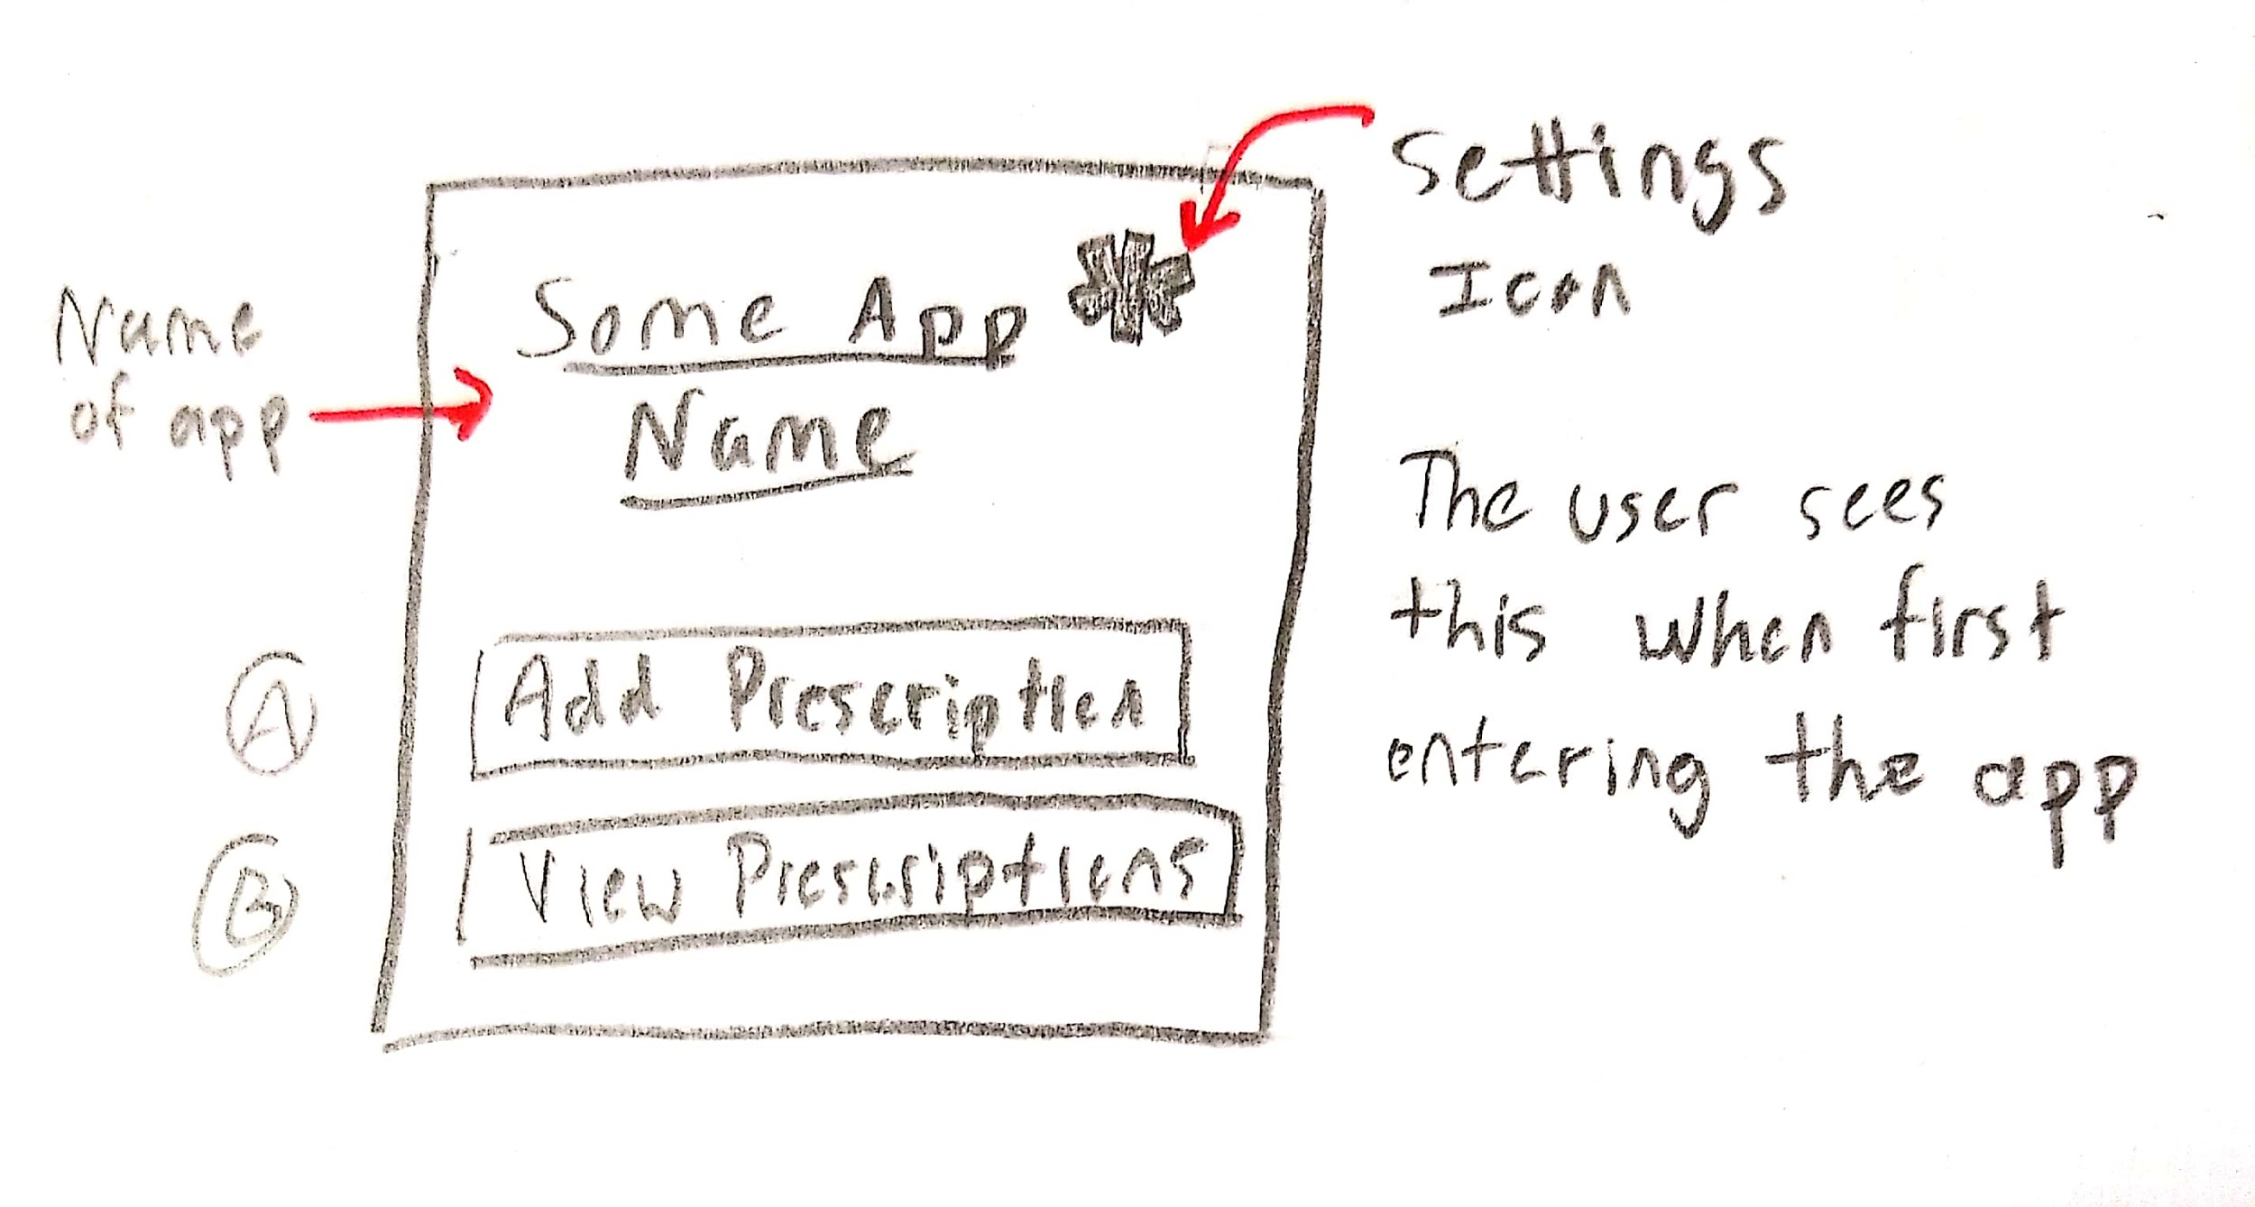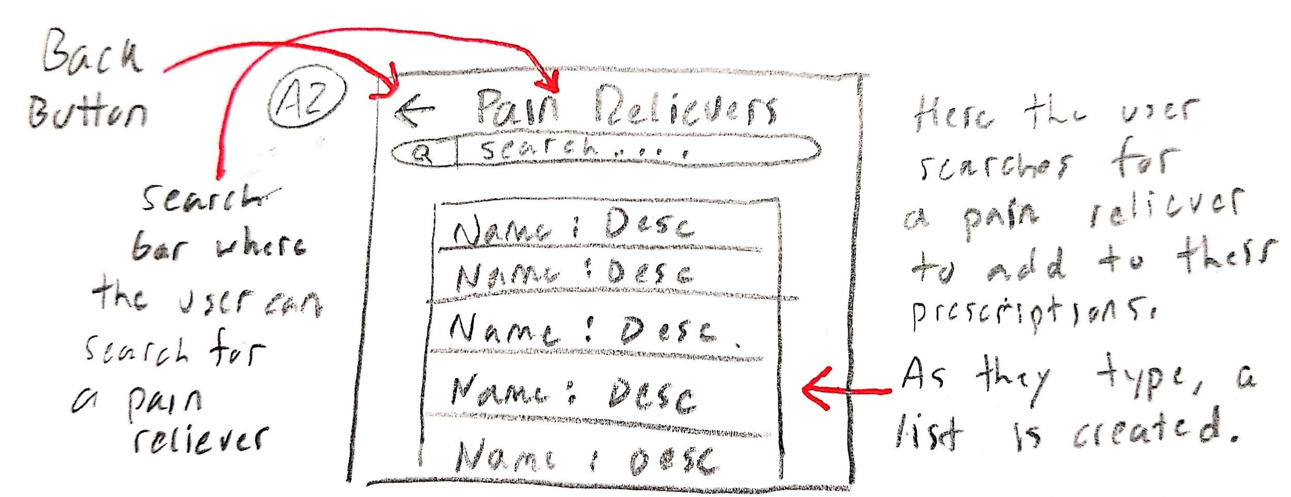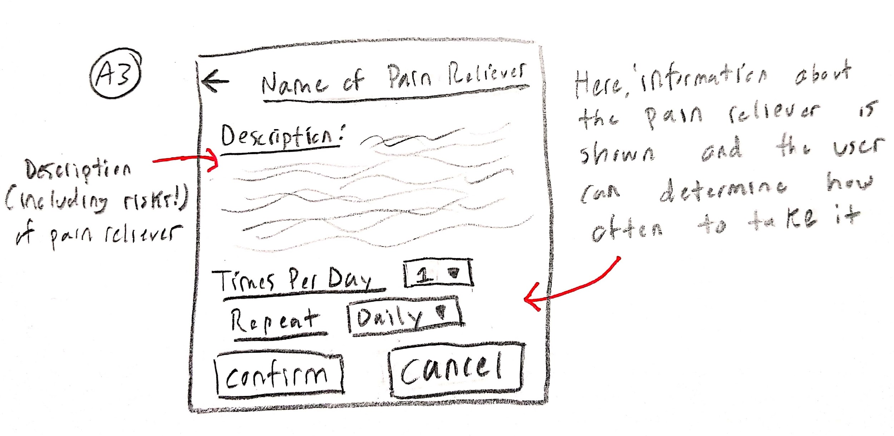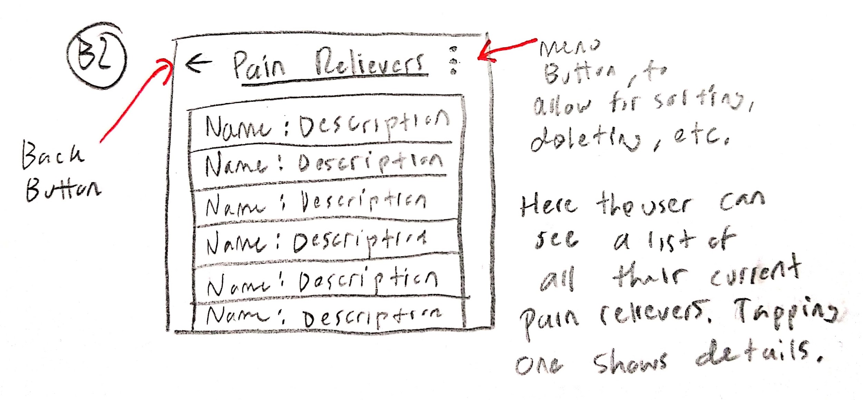

**Design 2:**

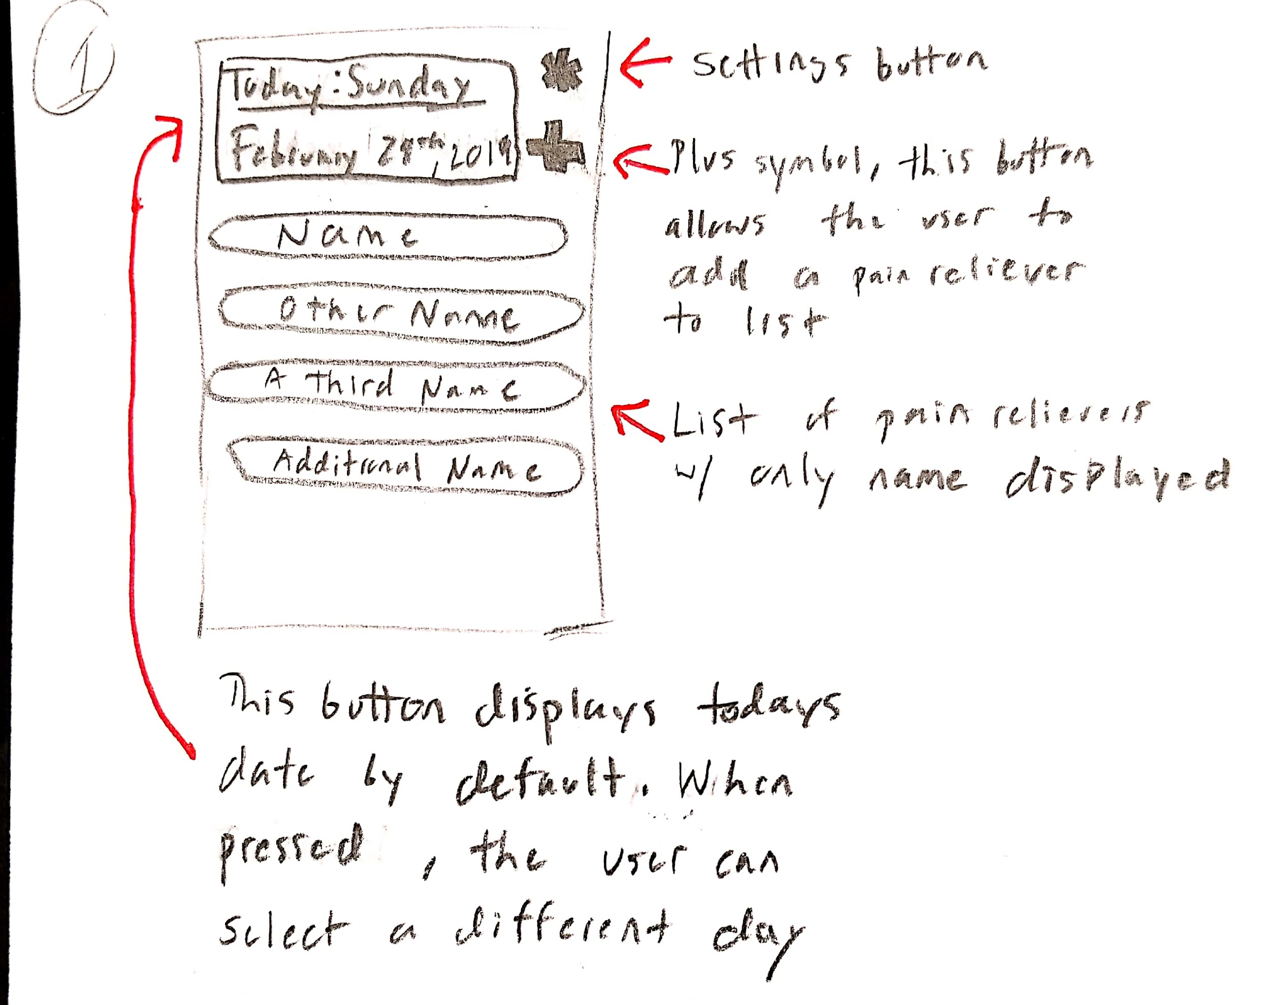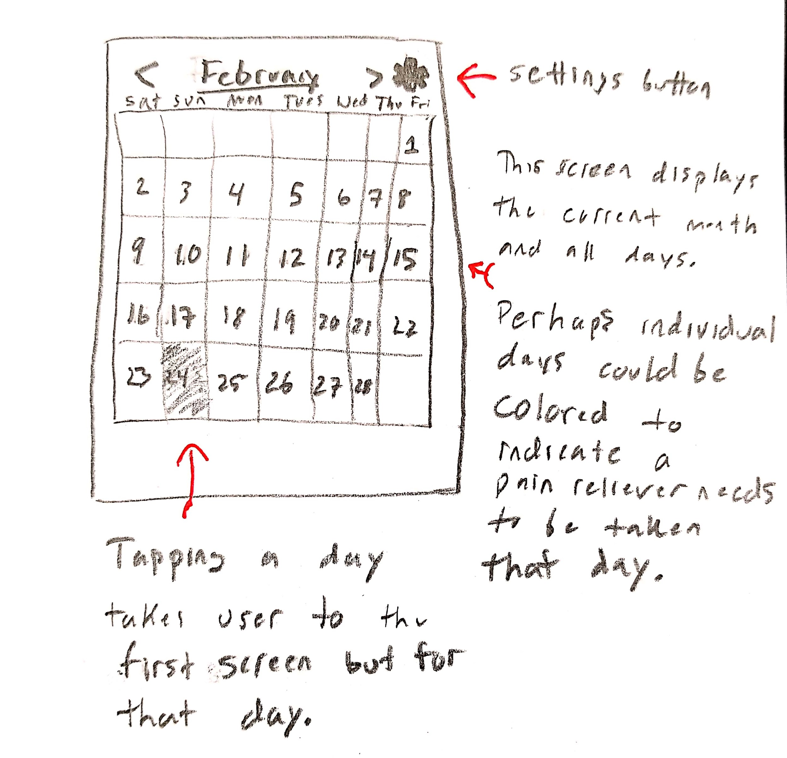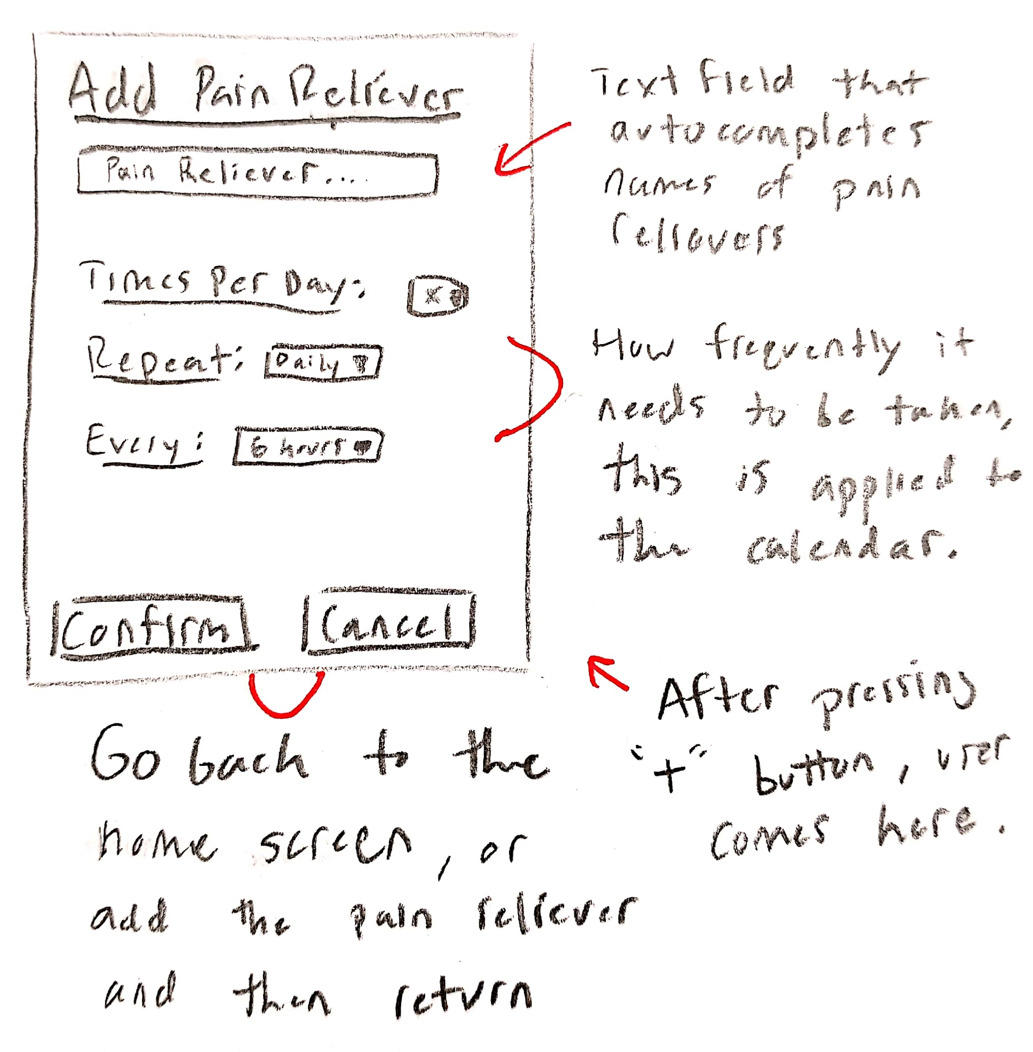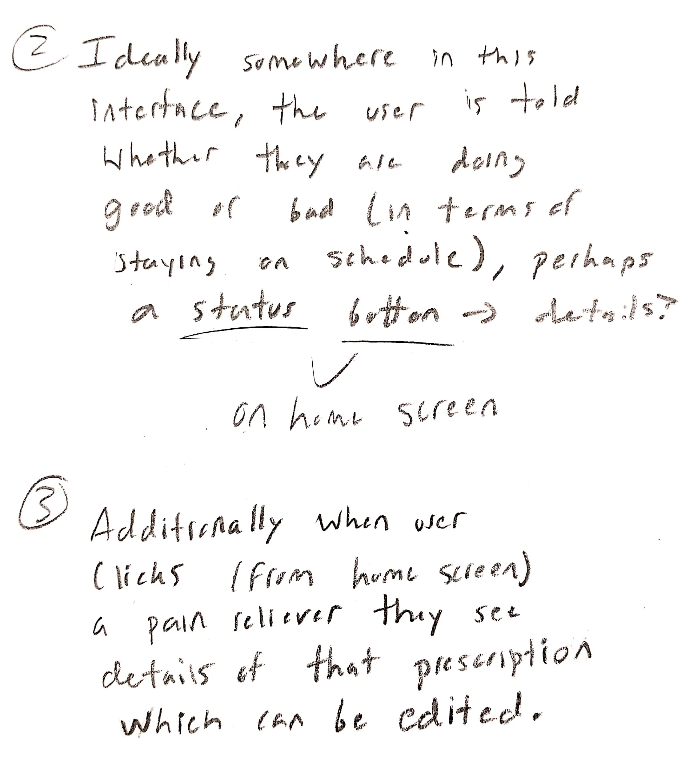

**Design 3:**

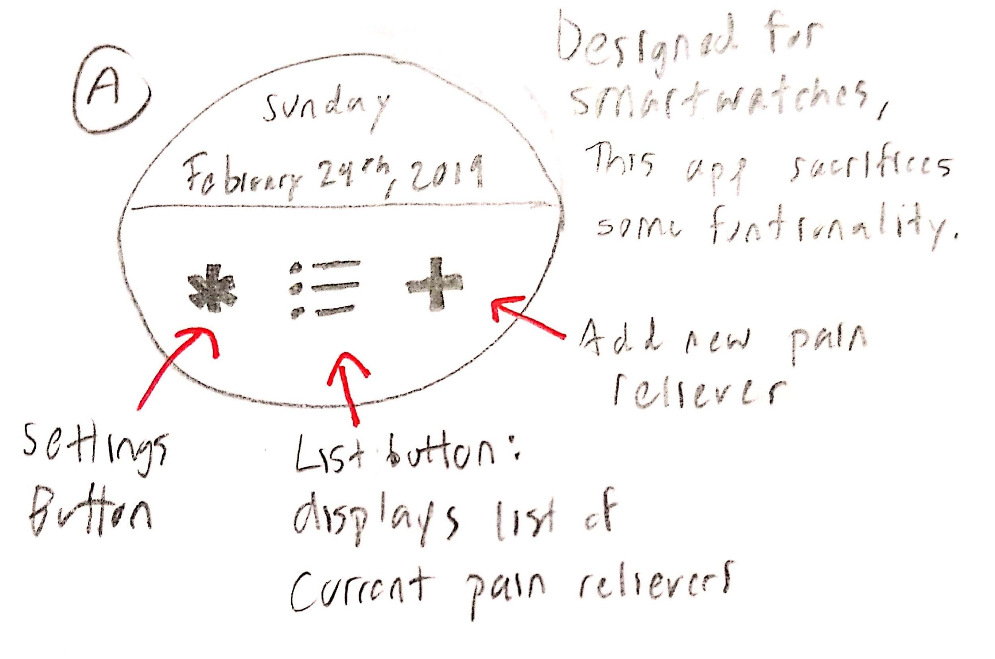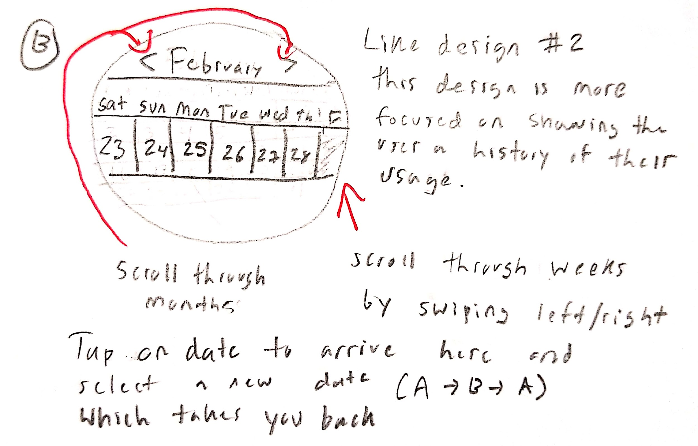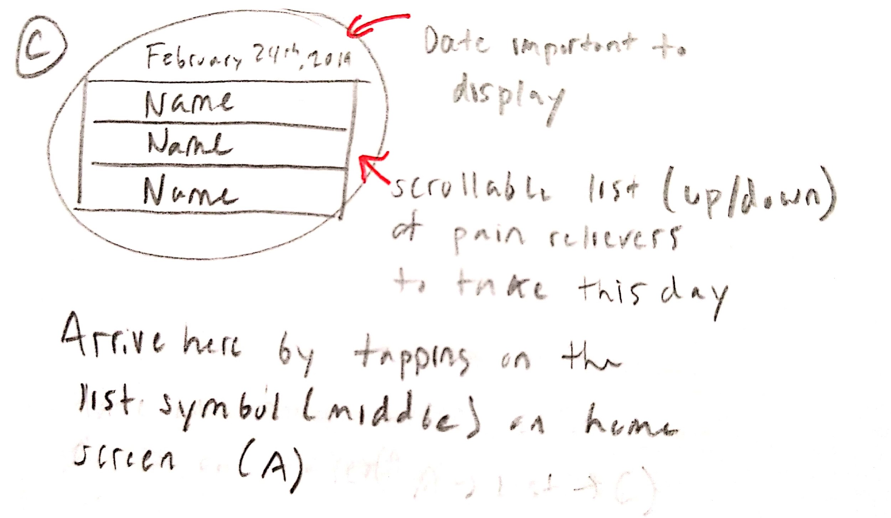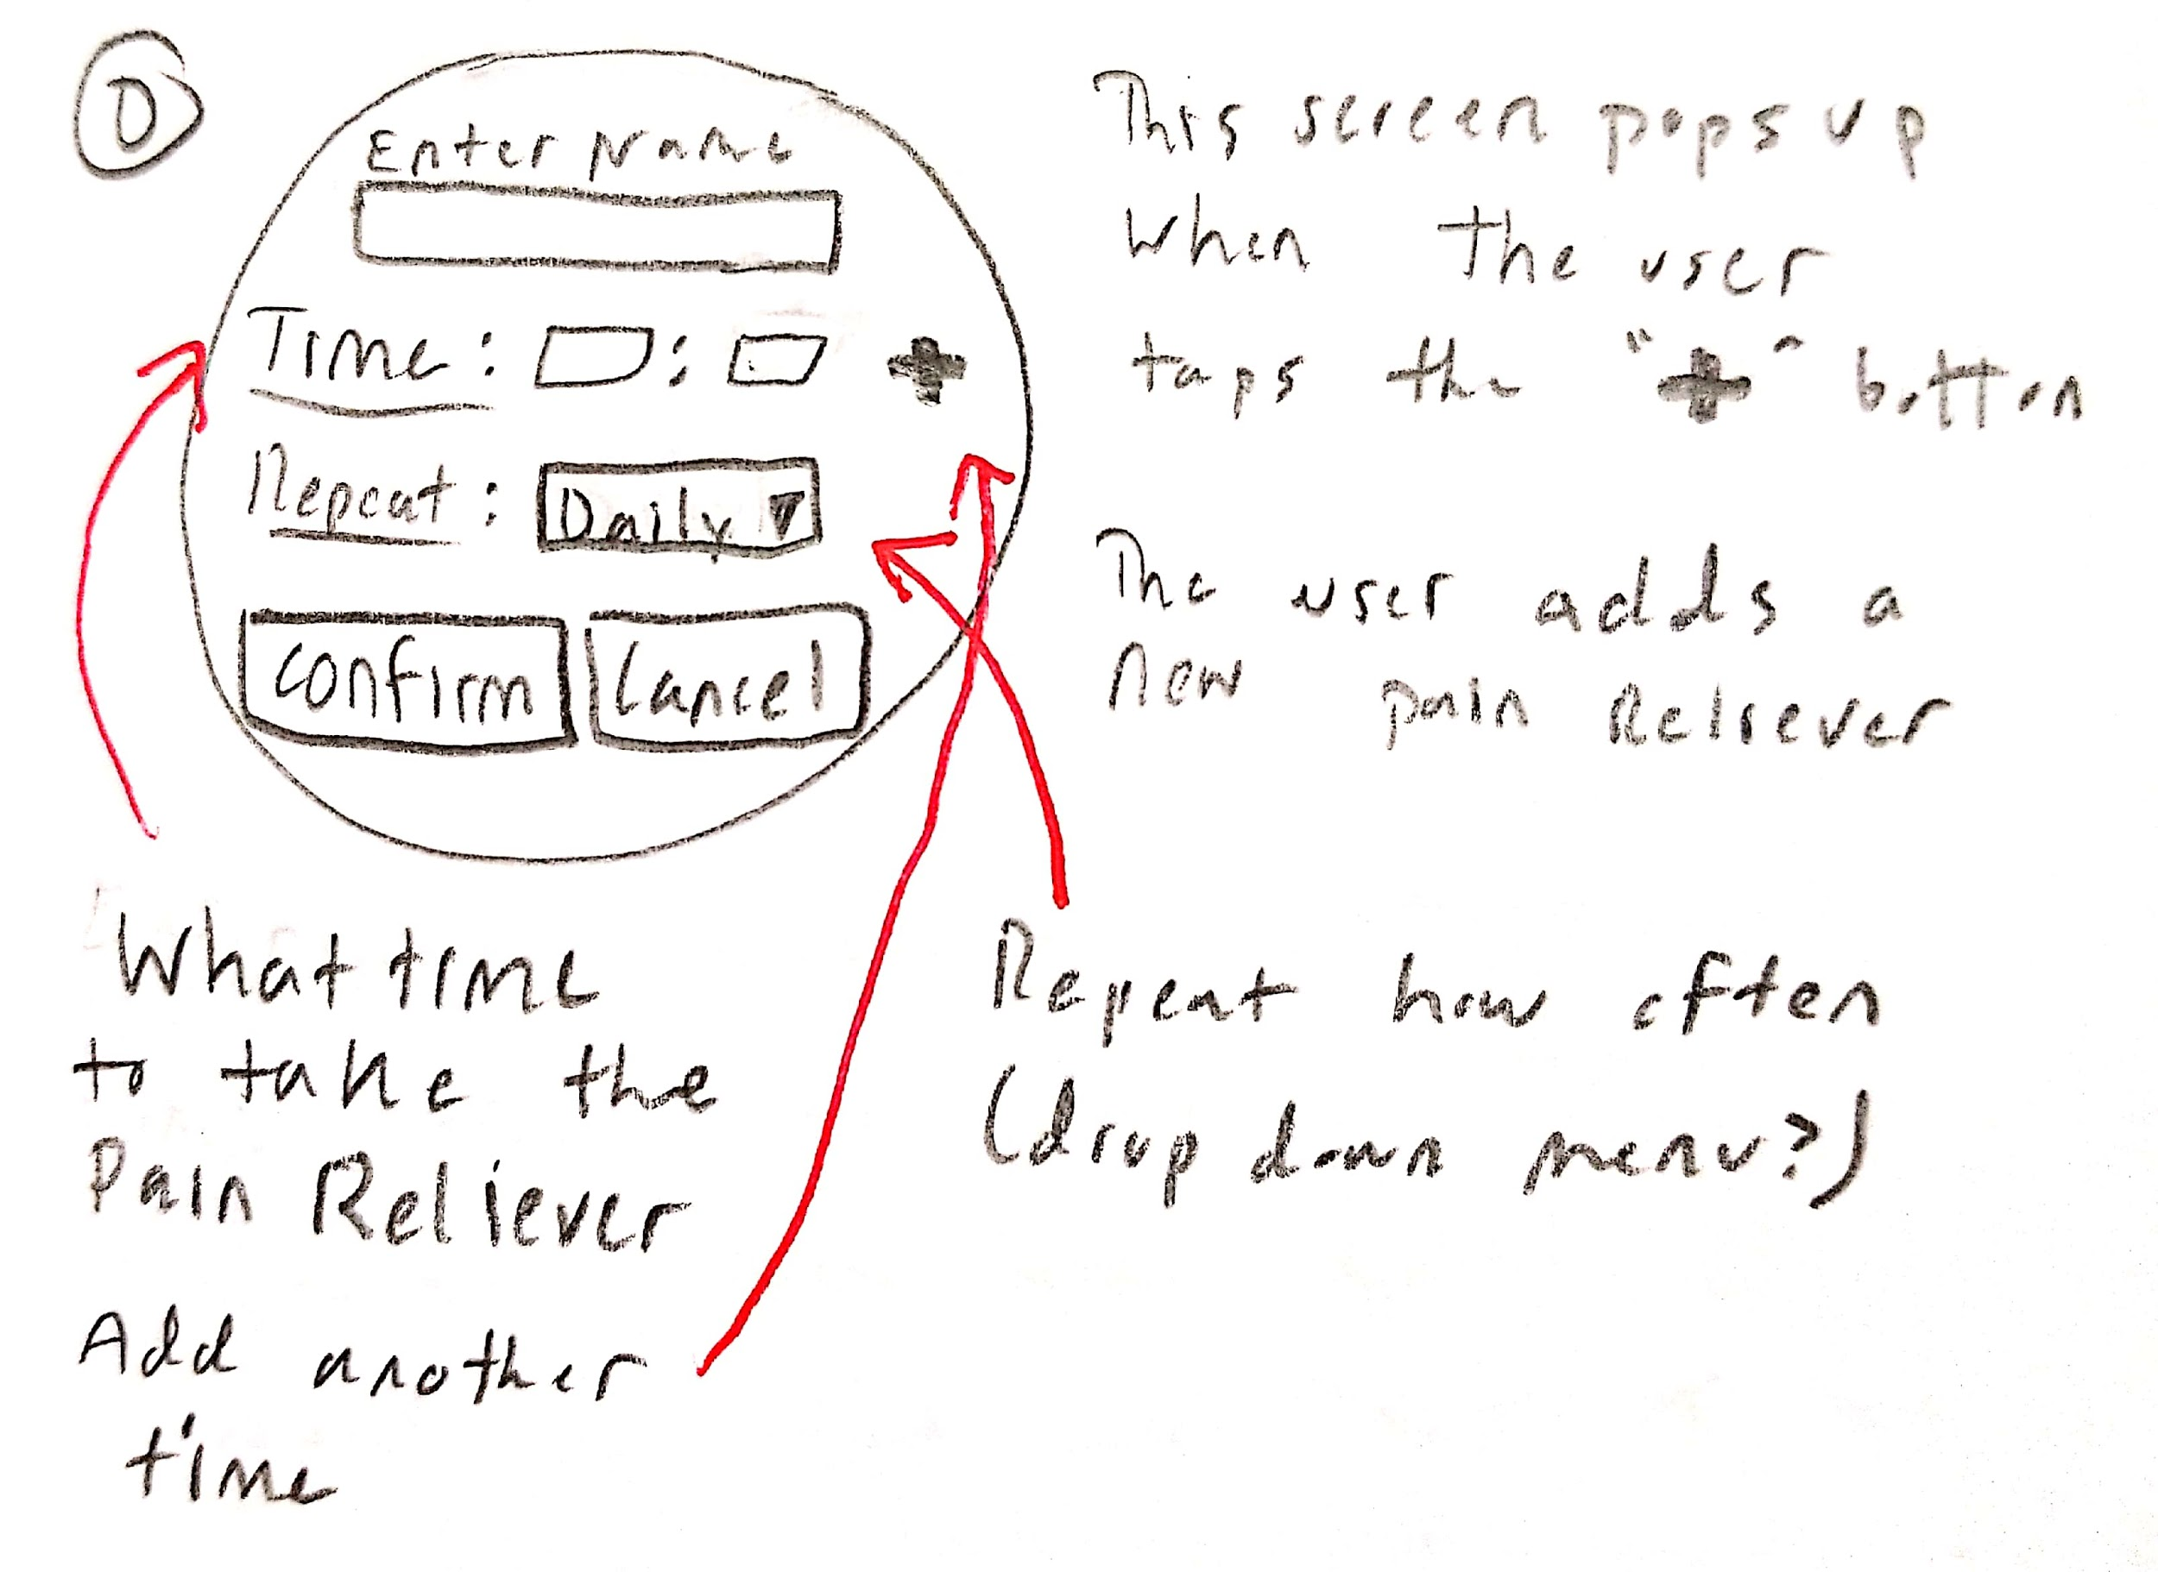

**Kathleen Mancillas**

**Design 1:**

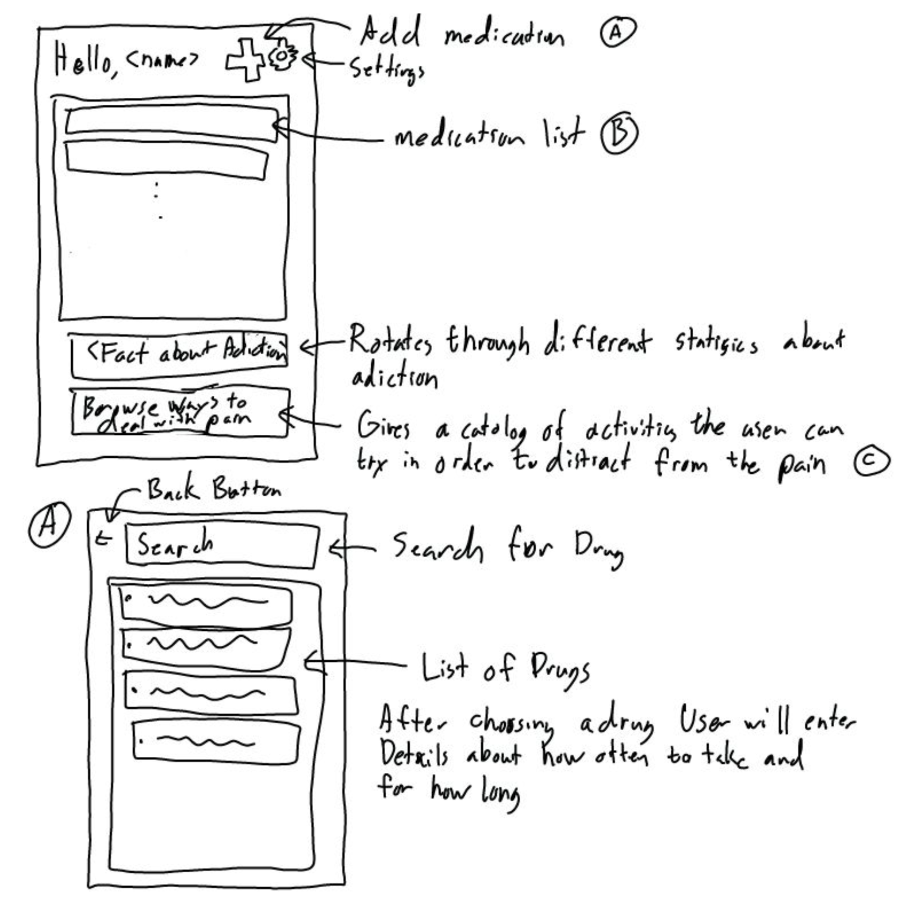

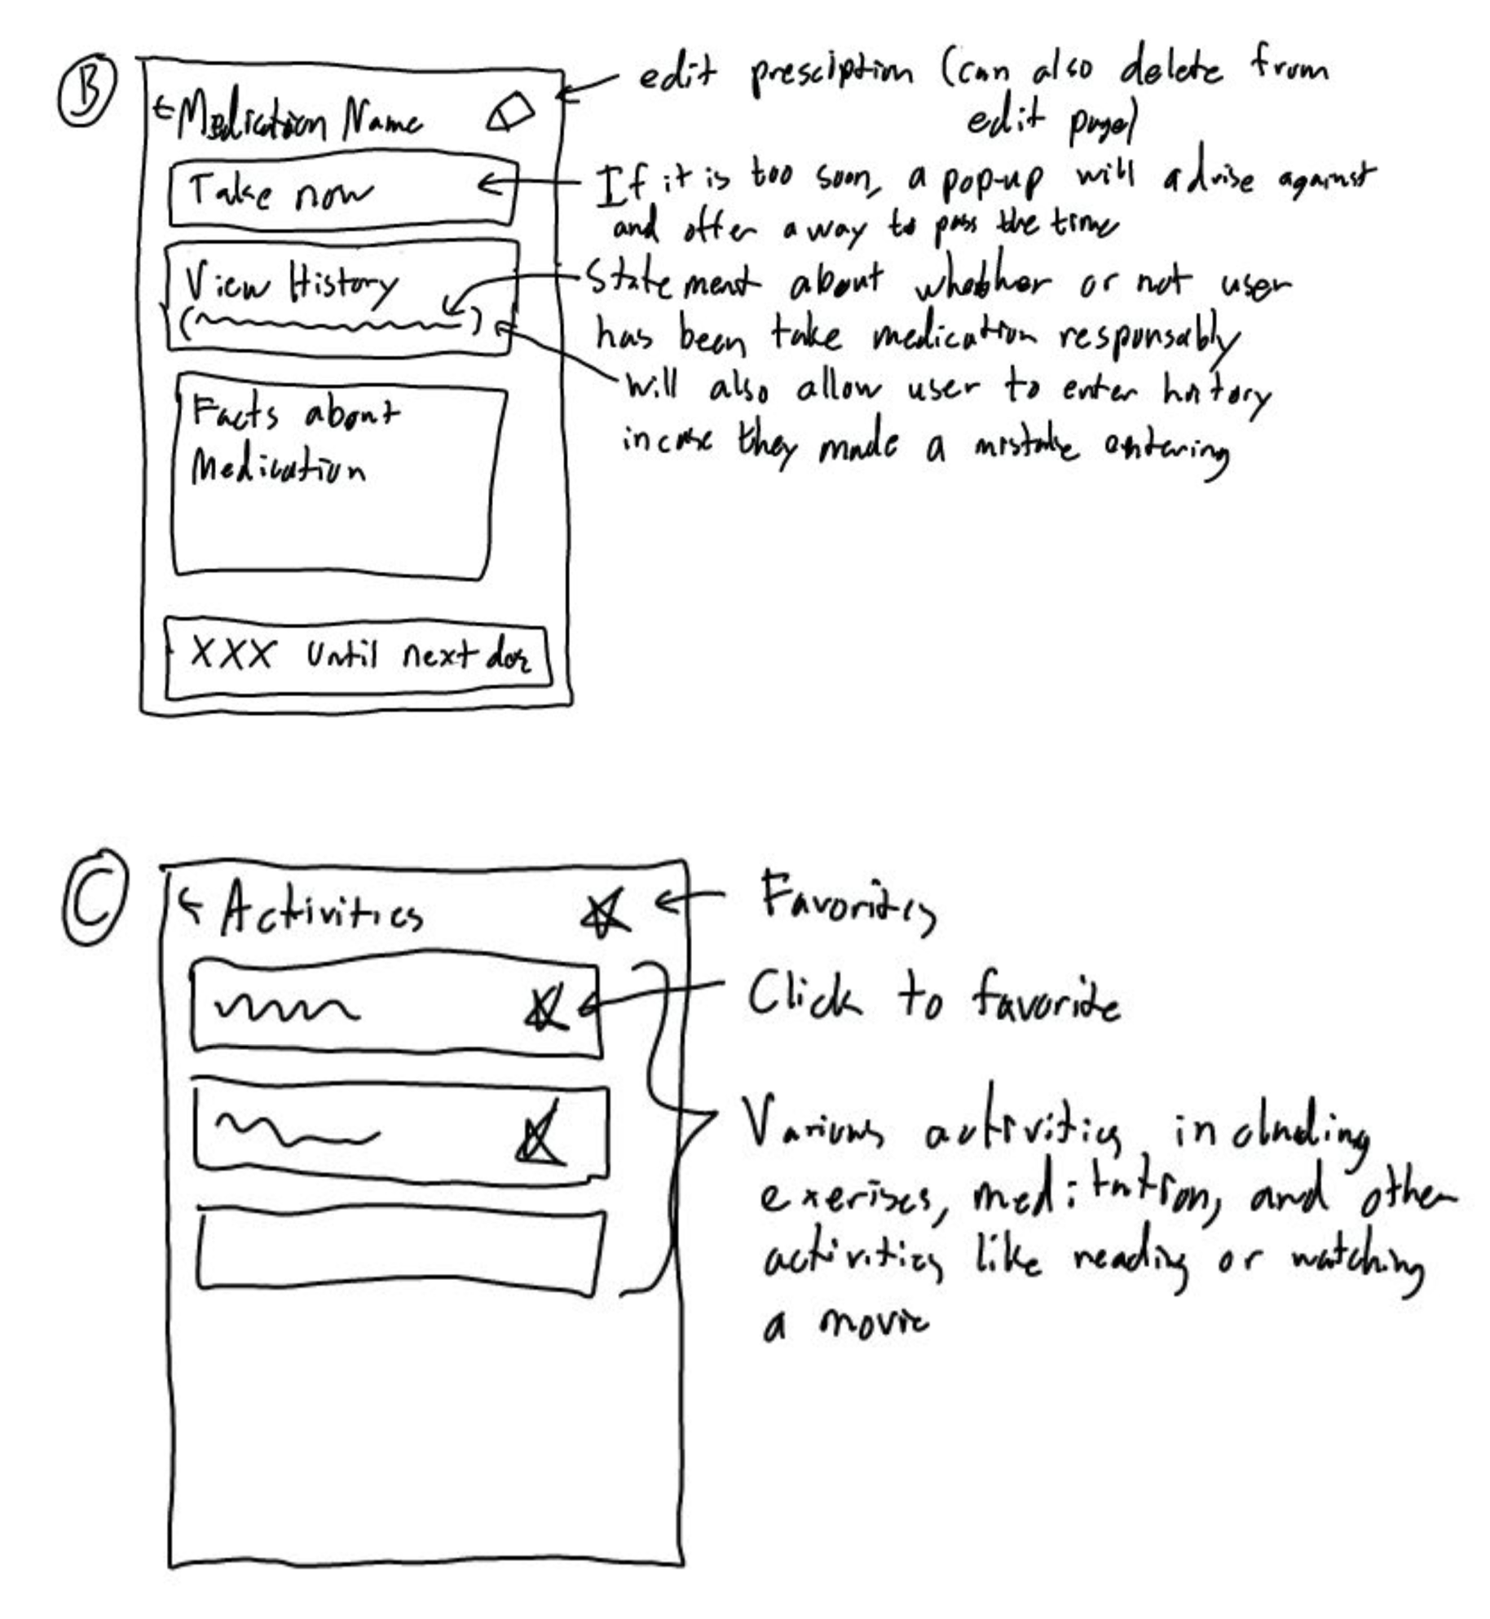

**Design 2:**

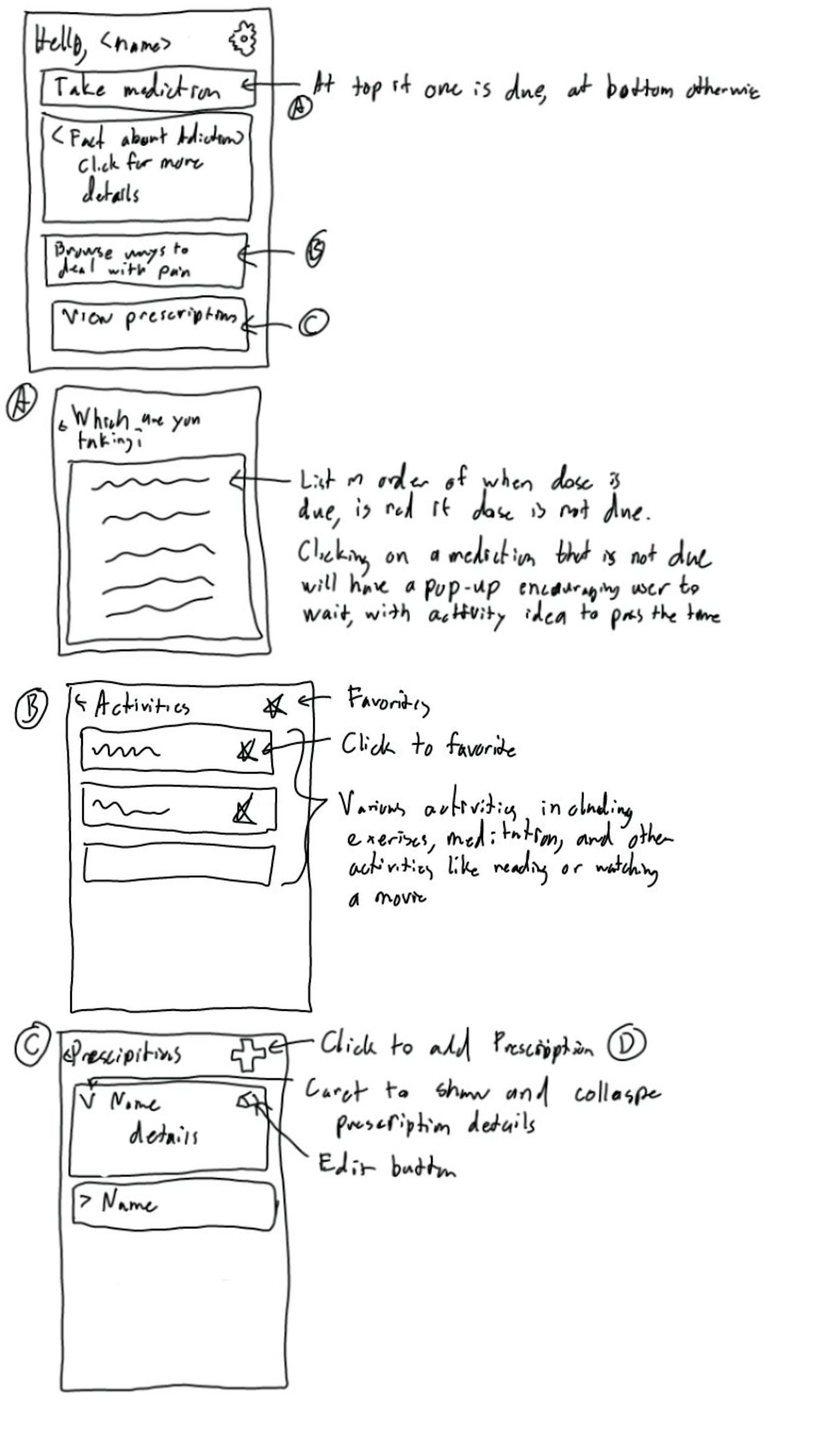

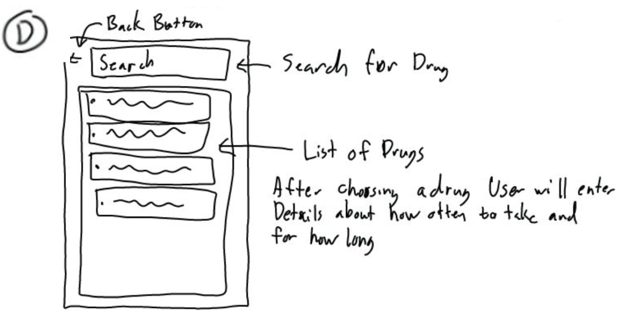

**Design 3:**

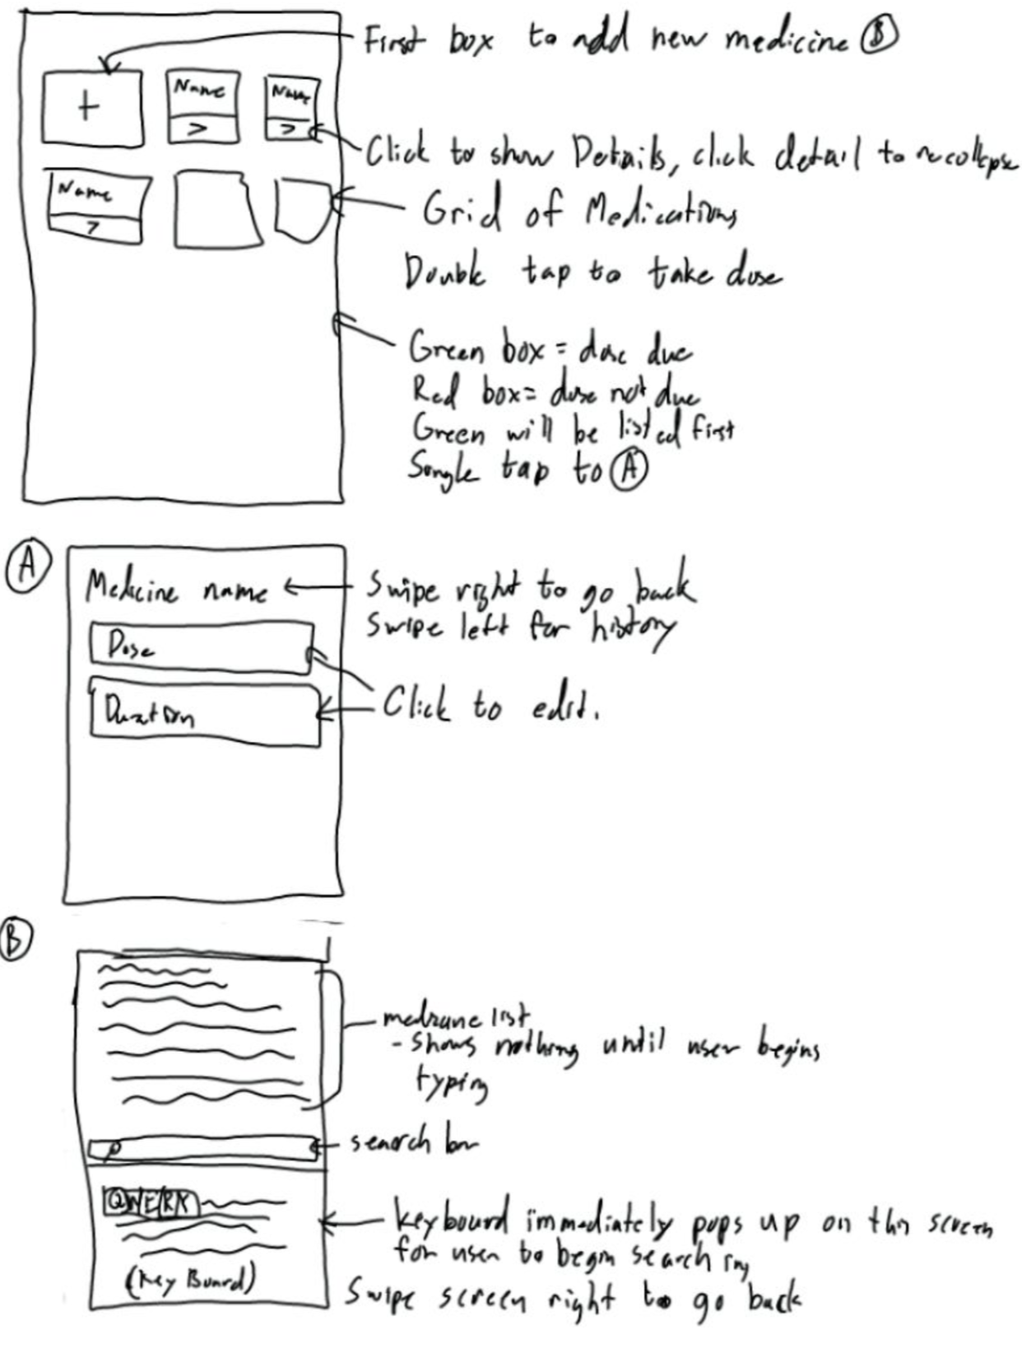

**Mohammed Shafiuddin**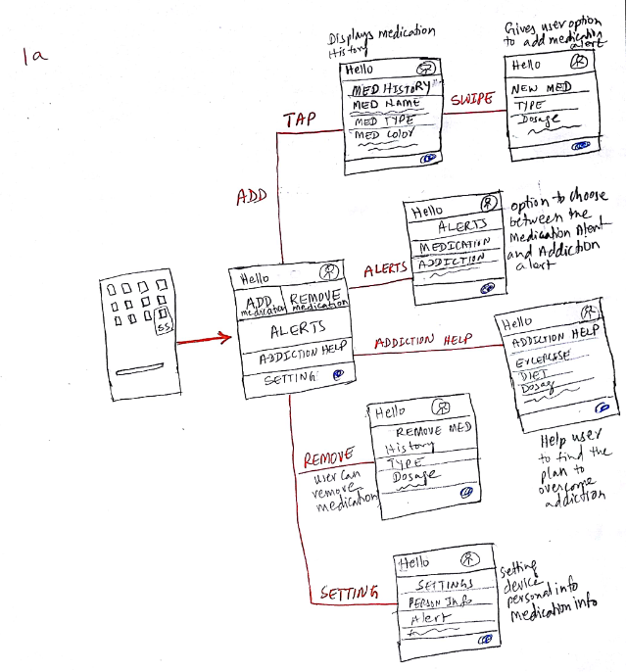

**Storyboards:**

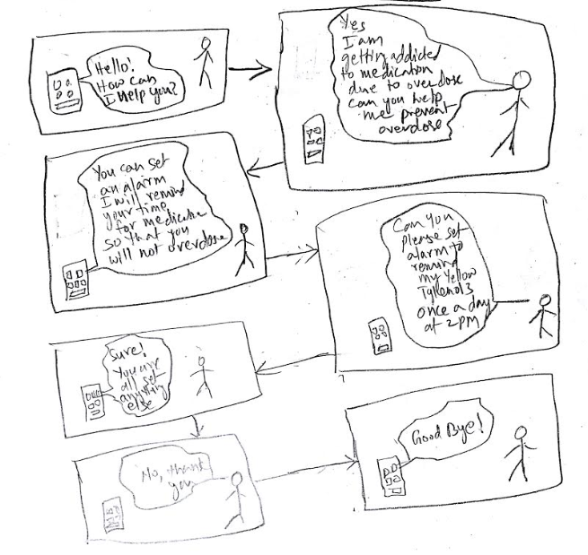

**Design 1:**

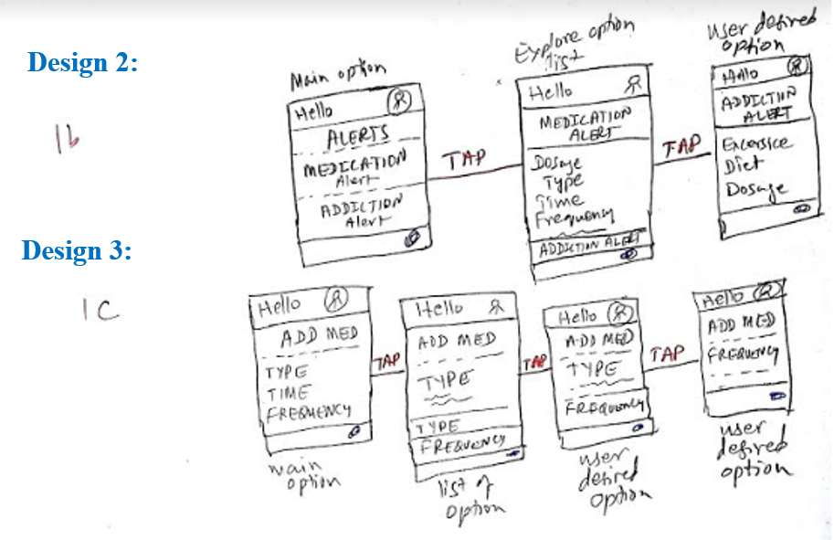

**Luqmaan Baiyat**

**Design 1:**

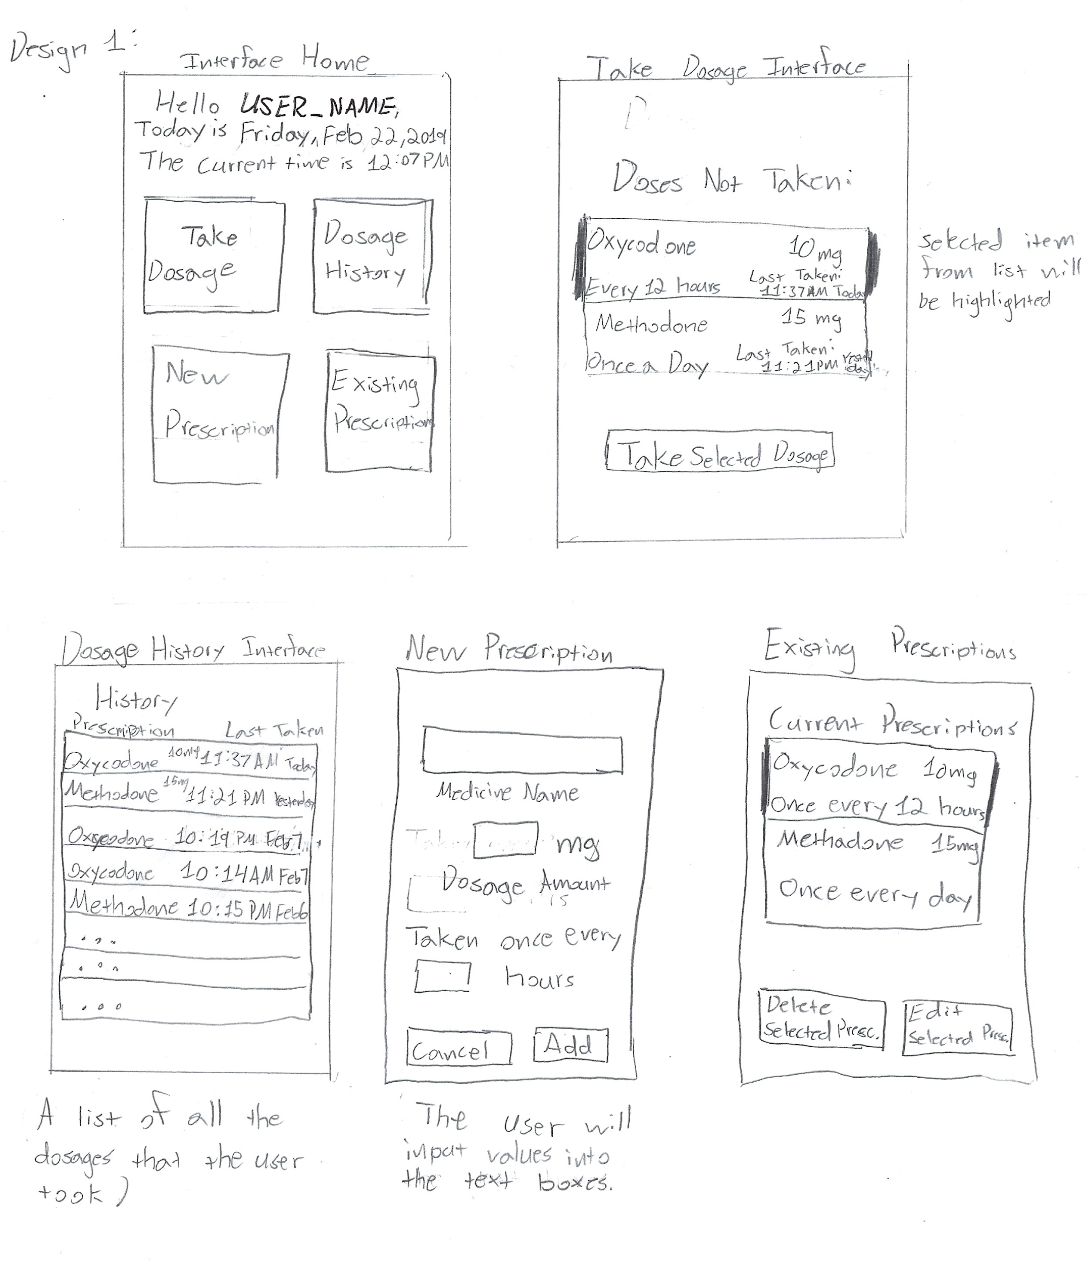

**Design 2:**

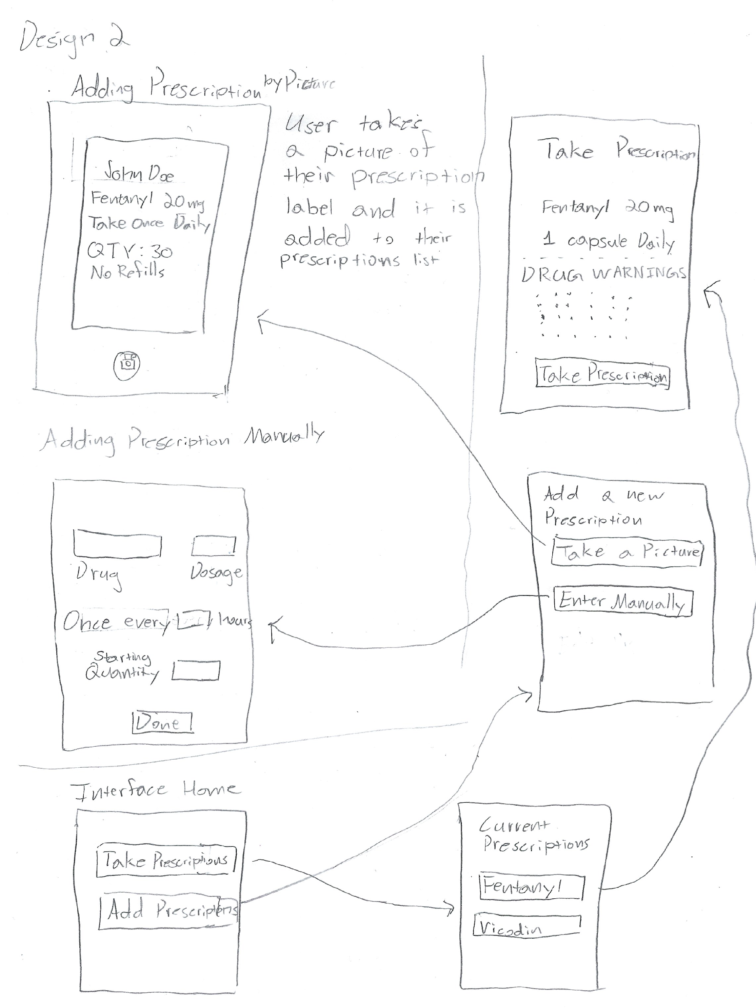

**Design 3:**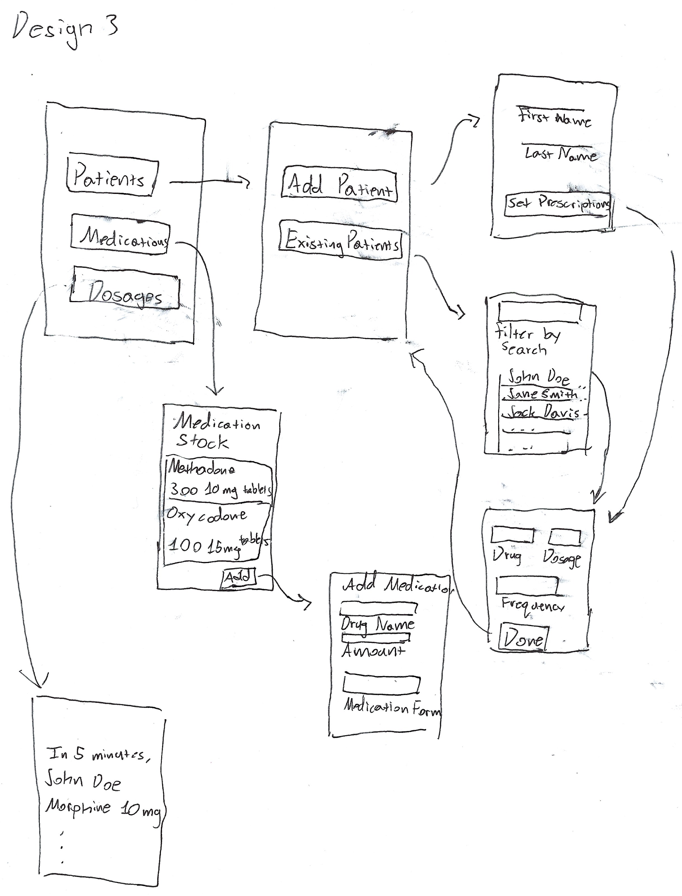

**Keval Patel**

The following shows the designs of the mobile application that can be used by a patient to help them in keeping track of their medical prescriptions. The first goal of the application was to notify the user when they need to take their medication. As circled on the image below as (1) the user interface has the list of prescriptions for the user and a timer. The list of prescriptions can store more than one prescription. The timer will help the user to set their time according to the prescriptions given to them. For instance, a patient has three prescriptions A,B and C. which are supposed to be taken at different times of the day. The user can set the timer to ring with Tone A for prescription A at a particular time as prescribed by their doctor. They can set the timer to ring with tone B for prescription B at the prescribed time and the same can be done for prescription C.

The timer can be set to automatically ring after certain span of time for each of the prescriptions. With that their will be no confusion or mix up unless the user personally chooses to ignore the time or the alarm.

The second goal for this application is to constantly inform the user of the dangers of the addiction. As circled in the image below as (2), the user interface of the application will be giving the user the list of the drugs they have on prescription and the ones they had initially used on one side and the effects of each drug on the other side. The details of how the consumption of drug can pose danger to their lives is given. It gives the user the ways in which the drug or the prescription can lead to addiction. It also warns the user on the short term effects of misusing the drug as well as the long term effects of the drug misuse.

The third goal of the mobile application is to provide the user with alternatives. As depicted in the image below as (3), the window provides the user with “My options”. The user is supposed to choose one of the availed options for instance Pain, the selection would bring all the available options to relief pain without interrupting or replicating the already existing prescription. This will help the user from taking drugs with the same components while thinking they have taken different drug and hence they will not affect anything. Most of the painkillers are made up of the same components and hence the user cn end up consuming an overdose without knowing.

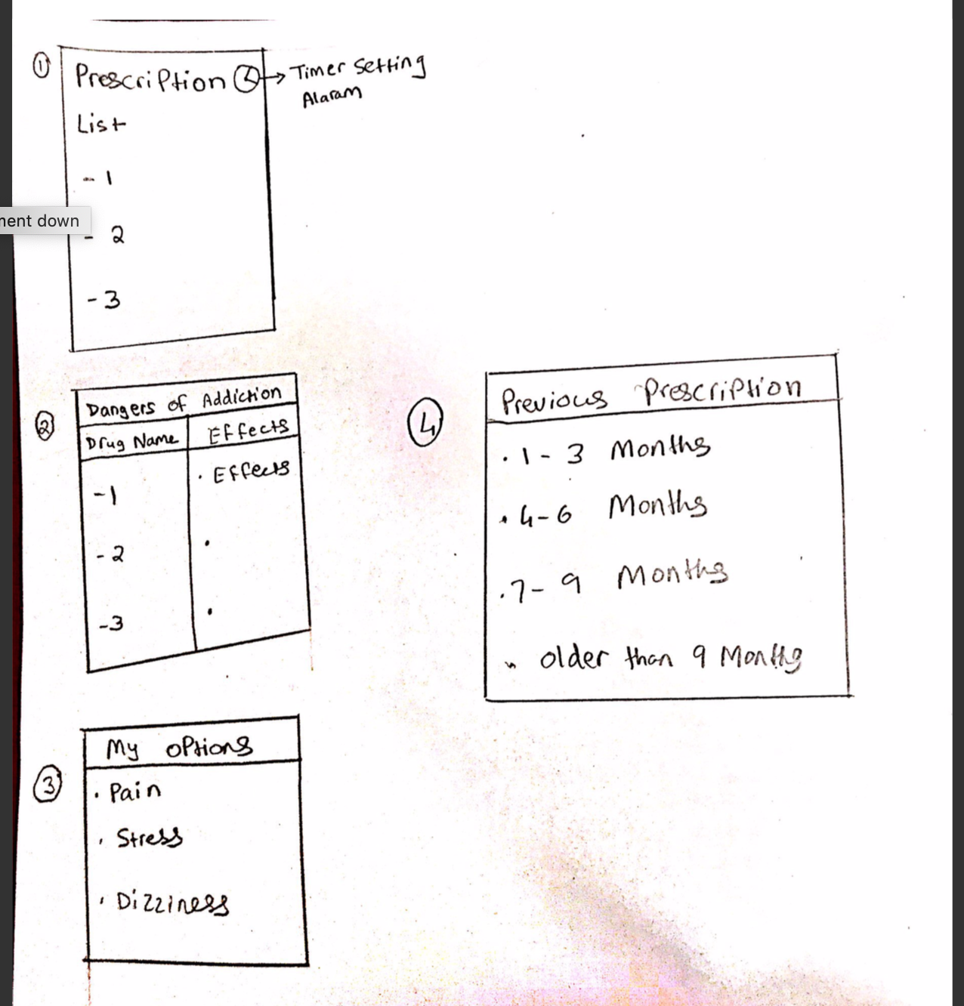

The other goal of the application was to allow the user to view some of the history of when they have taken their medication in the past and recently. The mobile application would achieve this by adopting the design circled as (4) in the image above. The window of the application is indicated as “Previous Prescriptions” and it has option for the user to choose from. For instance, they can choose to view their medical history for the past three months. All the medications that had been fed into the application will be populated starting from the most recent to the older prescriptions. The user is able to view their records in a span of three months to the time they enrolled into using the mobile application.

The fourth goal of the mobile application was to discourage the user from taking medications when they start using it more frequently. The application would incorporate the estimated duration that the user is supposed to finish their prescriptions and the application will notify the user not to consume a particular drug if the estimated time has lapsed for the drug use. The image below shows how the user interface of how to add a prescription which has the option to feed in the estimated duration for the drug to be out of use.

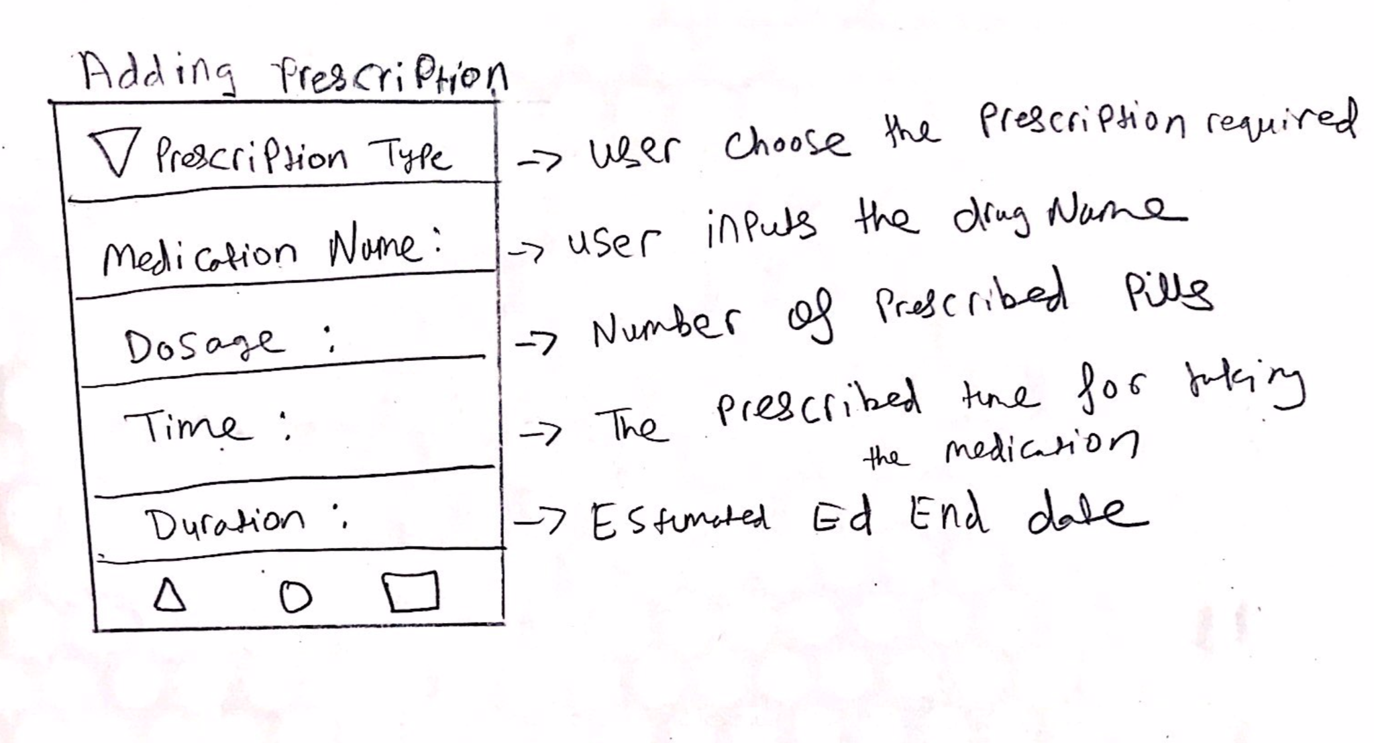

The image above shows the interface that the user will be adding the prescription to the application. The interface prompts the user to choose the prescription type, Enter the medicine name, dosage, time to take the medication and the estimated duration. The dosage prompts the user to enter the number of pills to take in one take. The duration covers the estimated number of days when the user takes the prescribed medicine with discipline. This will help warn them for addiction if they continue taking the dosage when the duration has lapsed.

**Group Designs w/ Storyboard & Analyses**

**Storyboards:**

**Phone set up for medication alert to prevent overdose that is leading to addiction:**

**Storyboards 1:**

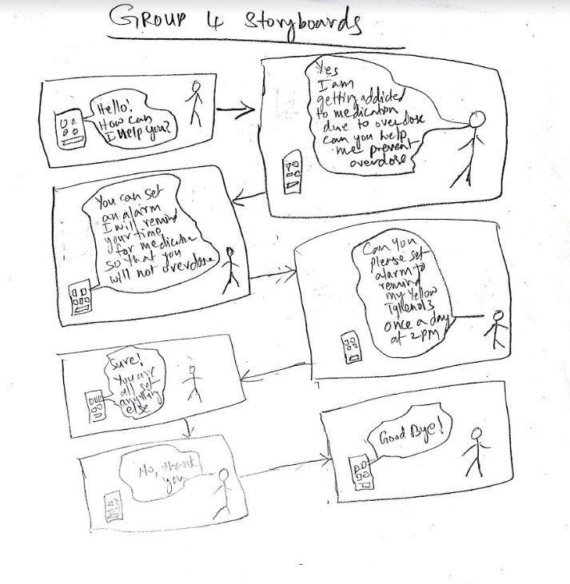

**Storyboards 2:**

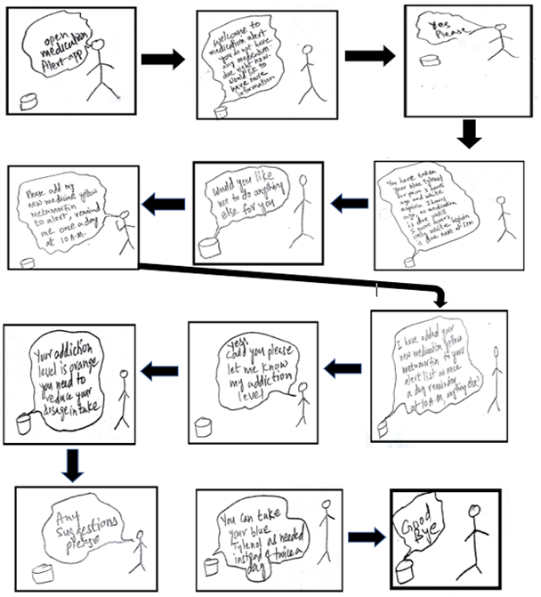

**Storyboards 3:**

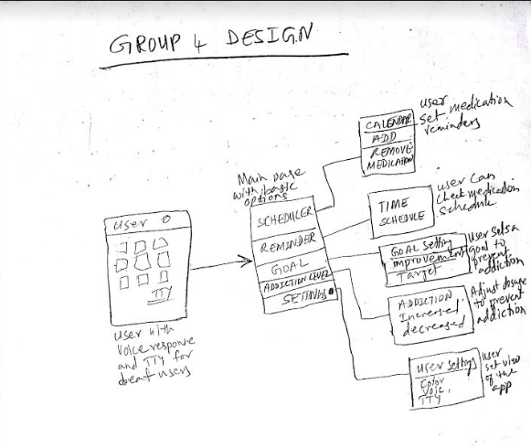

**Group Designs:**

**Design 1**

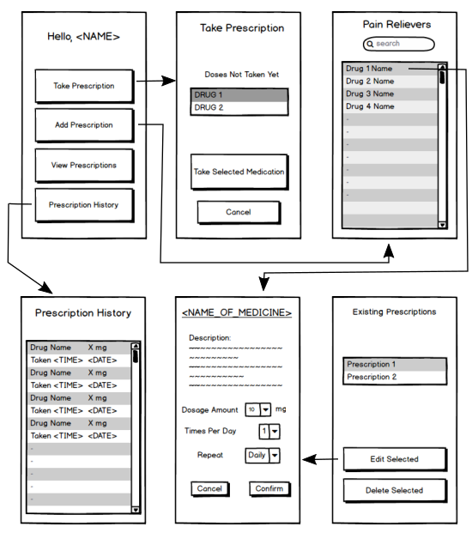

**Group Design 2:**



**GR3 Paper Prototyping**

**Prototype Images**

The images in this section are from the second iteration of prototyping. 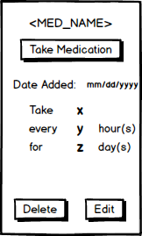

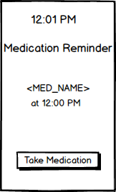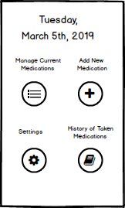

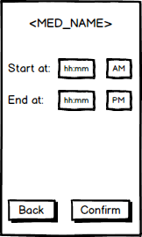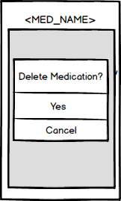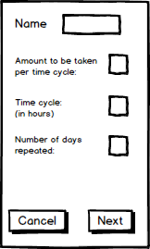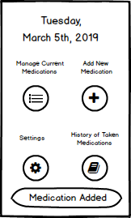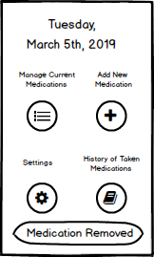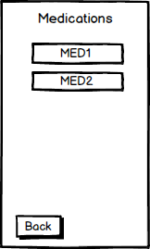

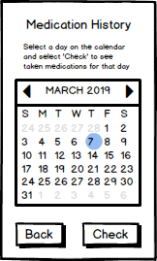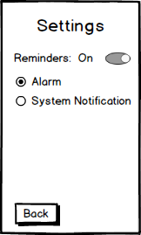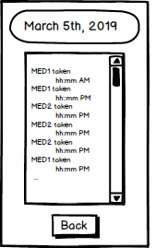

**Briefing**

The purpose of our application is to help people who use pain medications, such as Codeine and Fentanyl, keep track of their usage and be reminded when they need to take their medications through notifications on their phone.

Our app allows the user to add medications to a list. Each medication requires details such as the amount of times it should be taken per hour and what time they need to start being taken during the day.

Throughout the day, the user will get notifications on their phone which will tell them that they need to take the medication(s) they input. The users will have the option to confirm that they’ve taken the medication after selecting the notification. Besides that, the user has the option of seeing and editing their current list of medications.

**Scenario Tasks**

1. Add a new medication called “MED2” to be taken once every 2 hours from 12pm to 8pm, repeated for a week.
2. You’ve received a notification saying you need to take one tablet of MED2. Confirm that you’ve actually taken your medication.
3. Delete MED1 from your list of medications. (Assume MED1 was already previously added)
4. Change MED2 so that you only take it once per hour instead.
5. A week has passed. View your history of medications taken 7 days ago.

**Observations**

**Round 1 Observations**

**User 1:**

The user first encountered a problem on when attempted to edit a medication. The page from which a user views the details about a medication also looks as though one can directly edit, but in actually one needs to press the edit button first. The user also did not like the calendar page. Instead choosing one day to view, they wanted to choose a week to view. It is not obvious that picking a day will show the history from that day to the present.

**User 2:**

This user was slightly confused on the add medication page. Simply showing “ ‘blank’ per ‘blank’ hour(s)” was not sufficient. It took them a few seconds to realized was that meant. This user was also confused by the edit page the same way the first user was and also did not like the calendar page.

**User 3:**

With our prototype, it was unclear that clicking on a blank to enter numbers would cause the phone keyboard to pop-up. Next, the user did not like that there was no confirmation after adding a medication. It made them feel unsure if it really added. The major problem occurred when attempting to edit the details of med2. The user went to “medication history” instead of “pain medication” from which there is no way to edit the medication. The main problem that mislead the user was the fact that the label says *pain* medication. But is every medication added to the app only pain medication or are there other types?

**Round 2 Observations**

**Users 1 & 2:**

These users had few problems with the scenario tasks. They clearly understood when a medication was added and removed. The notification, for when a medication needs to be taken, was also a straightforward task.

However there was still uncertainty when editing a medication. It wasn't clear whether the user was able to edit on the edit screen (and the start and end times for the medication were missing).

When viewing the medications taken from 7 days ago, both users were unsure what to do when they saw the initial list of taken medications for the current day. They were able to figure out that they could select a different day by tapping the date but only after some hesitation.

**User 3:**

While performing Task 1, the user was stuck for a short period of time because they didn’t see an option to set the start and end time of the medication. They made it clear that setting the time on an exclusive interface was not intuitive, and suggested that all of the input options for adding a medication be laid out together on the same interface.  
  
 For Task 2, the user felt a sense of redundancy having to click on a button labeled ‘Take Medication’ twice. First from the alarm style notification, and again from inside the application.   
  
 While trying to delete a medication for Task 3, the user commented that if they wanted to return to the home screen, there was no way to do so. After clicking the delete button, the user said that the presentation of the deletion confirmation popup was confusing because the prompt “Delete Medication” looked like a clickable item.

For Task 4, the user tried to edit the medication settings on page displaying the medication information before finding the “Edit” button and clicking on it.

During Task 5, the user wanted some way to know what the current date was before they went and completed the task.

Lastly, the user thought that the position of the settings button in the main menu should be swapped with the position of the taken medications button because they felt the bottom left position was more significant than the bottom right for the given presentation of the options.

**Prototype Iteration**

**Iterations: 3, Rounds of Testing: 2  
First Iteration: 3 Users Tested**

During testing we found that the Medication History and Pain Medications functions seemed ambiguous in terms of what exactly they do that differentiates them. This caused confusion when a user was looking for a way to modify one of their medications and caused us to rethink the structure of our app.

In addition, our test users had some difficulty knowing whether or not they actually performed actions such as editing a medication or adding a new one. This taught us that we need to have some sort of feedback mechanism to assure the user their changes actually happened.

Finally, our users had trouble figuring out what they can input, and how, when it came to editing or adding a medication. As a result, we definitely had to figure out how to make the input method for each field (ex: names, time, amounts) more obvious.

**Second Iteration: 3 Users Tested**

During our second round, we still had some issues with the placement of our buttons, as users felt they weren’t in the right place. In addition, we figured that we were wasting time by having the user go through two menus when adding a new medication, so we changed that. The history was changed to only show the current date and the list shows up for the date first (that is, the calendar doesn’t show up first anymore).

**Changes between Prototype Iterations**

**Iteration 1 to Iteration 2**

* In the Main Menu we changed the names of what were previously called the Pain Medications and Medication History options to Manage Current Medications and History of Taken Medications respectively. This was done to make it clearer what both options do.
* We also added feedback messages in certain areas, such as after adding/deleting a medication so the user is completely sure that the action they just performed actually took place.
* Reformatted the Edit Menu to make it more clear about what the user should enter and where.
* The first part of the history interface now gives context for the highlighted date by letting the user know the selected date’s medication history will be brought up.

**Iteration 2 to Iteration 3**

* Made a single screen to add a medication by combining all of the fields in one screen instead of the previous procedure which involved two screens.
* For the confirmation popup received when clicking delete on a medication, the prompt “Delete Medication” was displayed differently so not to look like a selectable option from the user’s point of view.
* The screen showing medication information now has the delete and edit options towards the top of the display. This was done to accommodate a newly added back button, as well as letting the user see the edit button before they try to interact with the information labels.
* The calendar screen that the user interacts with to view medications taken for a particular day now shows the current date.
* The alarm notification page’s button was changed to “Proceed” from “Take Medication” to reduce redundancy.

**GR4 Computer Prototype**

**Platform Details**

Our project is implemented in the form of an Android app, which means an Android device is required. The minimum Android OS version needed to run the app is Android 8.1 (Oreo).

**Instructions**

Below is a link to the code of our app. It is an Android app developed in Android Studio and we used a Pixel 2 Xl using API 28 (Android 9.0).

[Prototype Code Zip File](https://drive.google.com/open?id=1JN_c6cd71xXxGOvcX8FhgPe9jxvcpb7t)

Additionally, we have provided a video of our app in action:

[Prototype Video](https://drive.google.com/open?id=18lkgzWl6NBuOc2yJ5hmqQkuWNi-ED-z7)

**Shallow Parts**

1. Of the four main menu buttons, the Settings button hasn’t been implemented.
2. Manage Current Medications displays a small list of already added medications. When tapping one, details of that medication are shown. This data is canned. Edit and Delete buttons do not have complete functionality, nor does Take Medication button.
3. Add New Medication allows entering data but doesn’t actually add the medication (i.e. Confirm button doesn’t actually go through with adding).
4. Medication History works but the information shown is canned.
5. The notification displayed is also canned and not specific to any medication.

**GR5 UI Development**

**Project Link**

[Project GitHub Repository](https://github.com/lbaiyat/CS422Group4Project)

**Platform Details**

Our project is implemented in the form of an Android app, which means an Android device is required. The minimum Android OS version needed to run the app is Android 8.1 (Oreo).

To make testing (and using) the app easier we simply ran the app on an emulated Pixel 2XL from Android Studio, the IDE we used to develop our app.

**Feedback and Other Details**

**Feedback**:

After pressing the button from home screen to “Manage Current Medications” the screen displays the list of Medications that allows users to pick the medication they like to manage, once the user selects the medication to manage, this opens up an option to Take, Edit, and Delete medication. At this screen, if the user decides not to change anything, then there should be a button option for the user to go back to Home screen. This satisfies the user control and freedom

of Nielsen’s heuristics, by allowing the user with an option for the emergency exit without going through an extended screen.

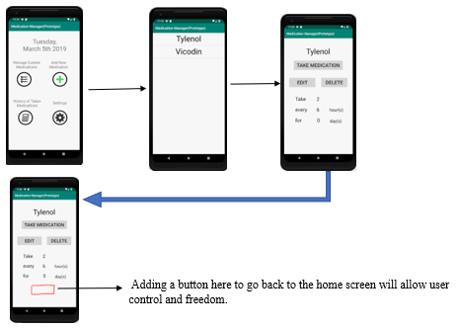

User can add medication by tapping an add button from home screen this will take the user to another screen to add medication, the fields in this option should inform the user while entering the irrelevant data such as if the user accidentally inserts the alphabets instead of numbers then the user should be alerted with the error message that prevents the errors. This will help prevent errors and will satisfy the error prevention heuristics. Additionally, by providing a check mark to ensure that the system was able to catch the edited field as shown in the image below with yellow check marks. Furthermore, after the user confirms by clicking “Yes” to add medication this goes back to the home screen instead it will be nice if the prototype displays the confirmed screens like the one shown below with the yellow check marks, and then at this screen there should be an option to go back to home screen. This way the prototype can satisfy the visibility of system status heuristics.

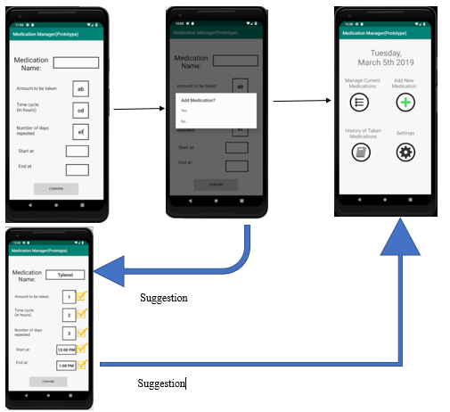

**Luqmaan**: Created the GitHub repository. Wrote nearly all the layout files. Developed the notification and medication history features along with the corresponding layout files. Helped figure out how to store data. Developed the Settings feature.  
  
**Jose**: Developed functionality for displaying the list of medications and adding a new medication in addition to all the layout files related to those features. Created the main menu functionality. Helped figure out how to store data. Created the original design of the app.

**Shafiuddin**: User testing by TA during studio session. Available to do any task assigned by any of the group members. Posted the Feedback.

**Studio Feedback:**

TA suggested more spacing between the buttons labeled *Edit* and *Delete* on the currently displayed medication page.

**Meeting Logs**

Group Meeting: 3/7/2019

Review:

Reviewed Medication history and Medication option design

Group Meeting: 3/20/2019

Review:

Discussed about the slides that we will be presenting tomorrow, attempted to ensure that the order of slides are in correct order,

Suggestions:

Medication history should be modified in way that user should able distinguish between the past medicine taken and currently taking.

During testing with User 3 when Medication History was pressed user had some confusion that I can’t recall, but looking at it at this meeting it is suggested that the implementation need to be modified to make it less confusion by narrowing the choices to optimize the UI. It is believed that the user was expecting to see a separate or dedicated window that has Medication History.

Remove pain medication option and place it into ADD option

GR6 User Testing

**General Layout, Colors and Typography**

Our final design is Medication Reminder is a mobile application. It was designed to increase the learnability and usability for the user that keeps the user informed about their selected tasks. The main colors are white, green and black.

**Contrasts:**

Green: White

White: black

The colors white and green are selected to keep the consistency and match with the real world, these are the institutional colors of healthcare facilities and the mobile application. Additionally, important information, titles and focus areas such as buttons and icons needed to be black and white, not any green.

**Font:**

Font family chosen for our layout is called Verdana, a sample is shown below:

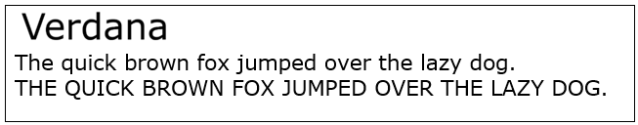

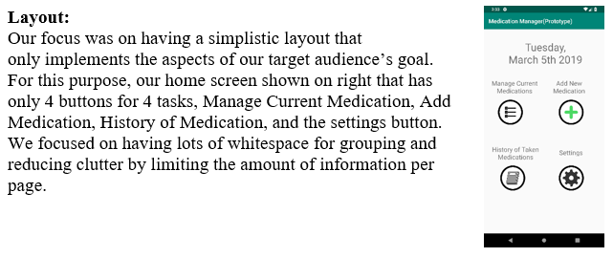

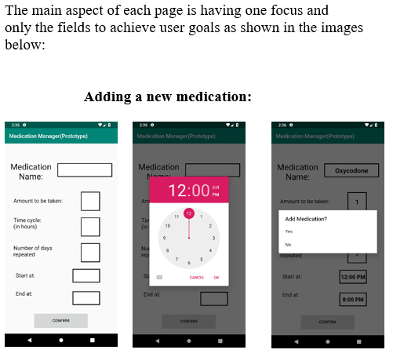

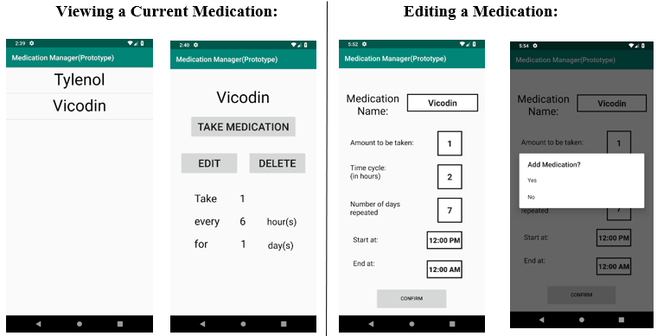

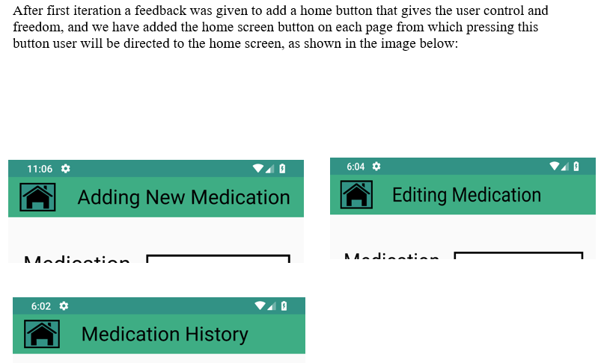

## **Implementation:**

## To implement this interface we used Android Studio.

* Home screen consists of 4 buttons that allows users to pick any of the 4 tasks, the tasks are:
* “Manage Current Medication”, Add New Medication”, History of Taken Medication, and the “Settings”.
* Manage Current Medication: Allows user to Add, Delete, Edit the current medications on list.
* Add New Medication: This will allow use to add new medication.
* History of Taken Medication: This lists all the medication based on the user defined date from the calendar provided.

**Evaluation:**

The user testing was conducted by having the users run the interface on the laptop. One team member was the facilitator of the user testing. The team member narrated the tasks and answered questions. The users were recruited through word of mouth by the team members.

The users are a 100% representation of our target population since our target population is older adults about 50ish and young once about late 20ish and up. There was a user aged around 51 and the other 2 were 27 and 28 approximately. After the user has been consented to do the testing, the facilitator informed the tasks all at once and in briefed in short sentences. After that, before each task, the facilitator asked the user again what was the next task. The facilitator has not done any demos before the user. This is because one of the goals of this interface is to be simply learnable and explorable for the target audience.

**User 1:** 26 years old:

When asked user 1 to add medication to our app, user was successfully able to navigate to the add new medication button, correctly added the name of the medication, correctly added the number of medication, and she was able to distinguish the option that lets user choose, number of days they want to continue taking that medication. After filling out the first three fields the user seemed a bit confused on what do next. Since we were doing our app on android studio, she didn't knew how to access button below it. After, we encountered the difficult she was having we helped helped her navigate by pressing back button on the virtual mobile device. However, she would not have encountered that problem if she had physical access to the app on her cellphone.

When user clicked on start at button, she was taken to the clock screen. She seemed confused at first but then later she was successful at adding start time and end time. After filling out all the fields, she clicked on confirmed button and screen popped up for conformation. User made sure that everything was correct and confirmed it, thus performing the task properly.

**User 2:** Early 50ish:

For user 2 testing, we asked user to delete the medication that user 1 added to the app. User seemed a bit confused, by the naming of the buttons. At first, he clicked on the settings to delete the medication that user added to the app, but then he was able to navigate to the medication history. After clicking on the medication history, he was taken to the calendar. It was very clear that user was able to identify that each day on calendar identifies medication taken on that day, he clicked on the day user 1’s test was performed from the calendar and deleted the medication added by user 1 on that day.

**User 3:** 28 years old Male:

For user 3 testing, we asked user to check the history of medication. The user was able to perform the task without hesitation. He was able to navigate to the medication history button and he was successfully able to see history of medications taken in the past. We asked him to see medication taken on specific date, he was able to figure out that upon clicking date on calendar, history would popup for that time period. User was impressed by the layout that was designed to see the previously taken medication for entire month or even a year.

**Reflection:**

During the design process, we got lots of feedback with ideas and criticism. We took the methods and explored them, one such example is having the home button on each page to give user control and freedom, and another example is have the confirmation message after user completing the task that provides system visibility and consistency. From our final user testing, we also learned that naming of the icons need more improvement, other than that most functionality where easily learned by users quickly.